**DATA CLEANISING:**

1. **Check for Missing Values**

**IS NULL:**

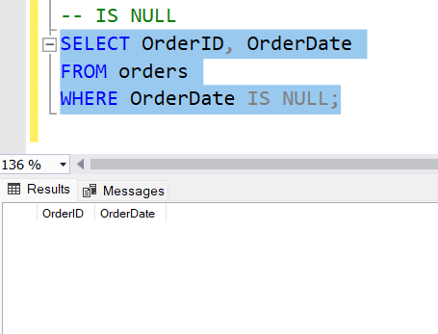

**COALESCE :**

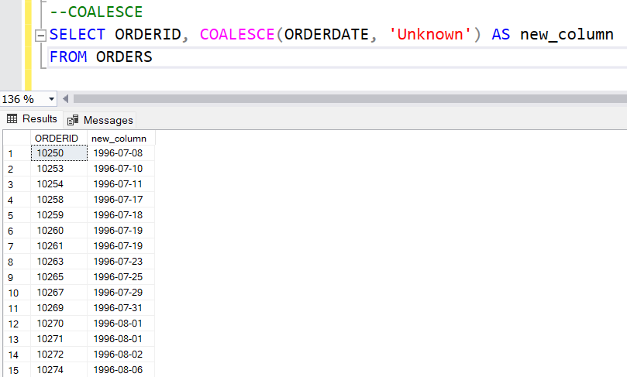

1. **Check for Duplicates**

**GROUP BY AND ORDER BY:**

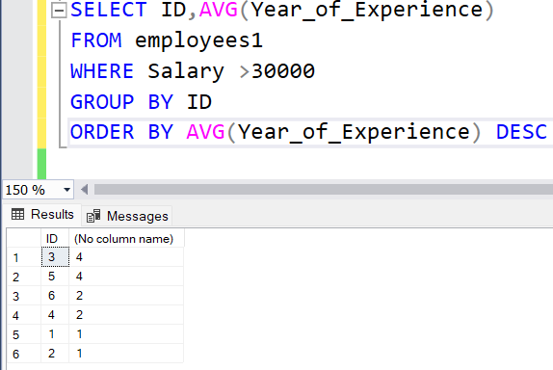

**DISTINCT** : SELECT DISTINCT DEPARTMENT FROM employees1;

**Output :**

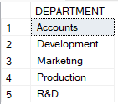

**DISTINCT & ORDER BY** : SELECT DISTINCT DEPARTMENT FROM employees1 ORDER BY Department DESC;

**Output :**

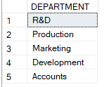

**DISTINCT & COUNT** : SELECT COUNT(DISTINCT DEPARTMENT) FROM employees1;

**Output :**



**DELETE** : To delete the records

**Query** : DELETE customers WHERE CustomerID=2

**Output** :

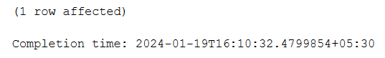

1. **Standardizing and Transforming Data**

**UPPER AND LOWER:**

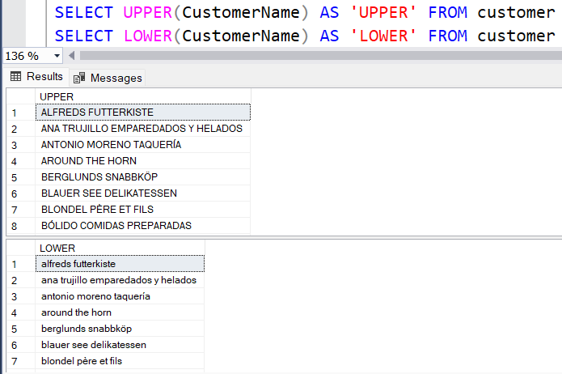

**REPLACE:**

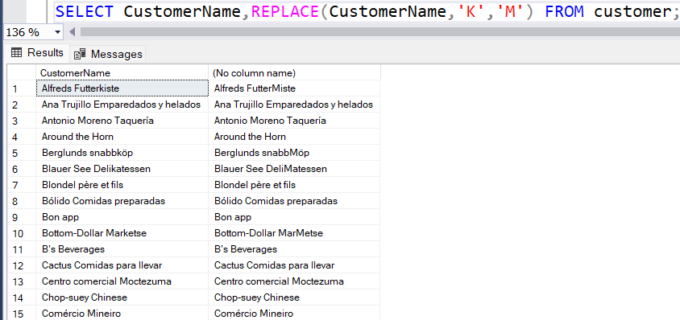

**SUBSTRING:**

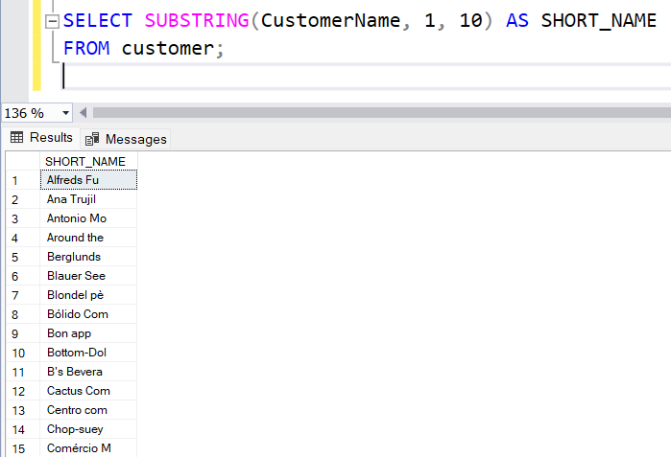

**TRIM:**

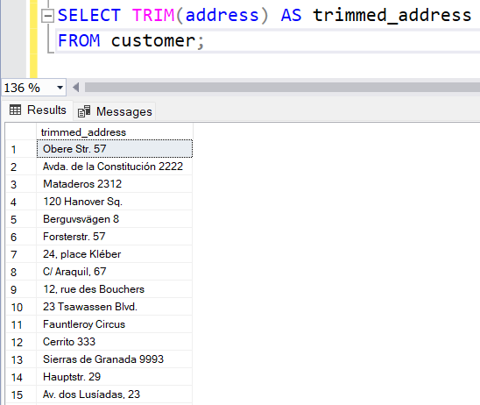

**CASE WHEN:**

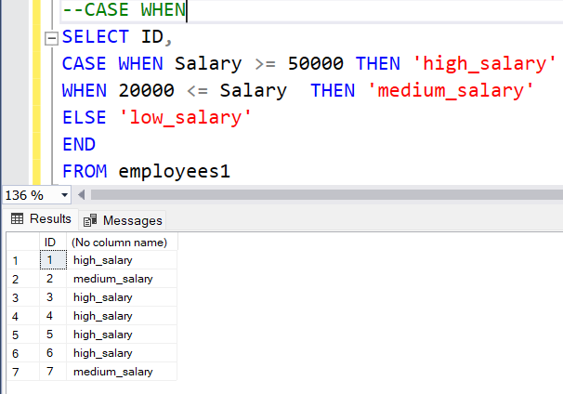

**4. Updating Data / Column Data Types**

**UPDATE** : To update the records in the table

**Query** : UPDATE employees1 SET Salary = 50000 WHERE ID = 1;

**Output** :

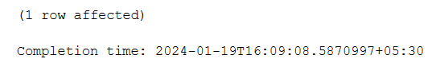

**ALTER** :

**To add a column :**

**Query** : ALTER TABLE EMPLOYEES1 ADD NewColumn INT;

**Output**:

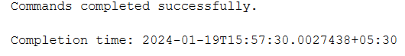

**To delete a column :**

**Query** : ALTER TABLE EMPLOYEES1 DROP COLUMN NewColumn;

**Output:**

